Order Of Service

Singing: Psalm 1—CW page 64

Reading: Psalm 67

Opening Hymn: TLH 94

Reading: Acts 8:1-3

Request Hymn: CW Supplement 707

Reading: John 16:25-33

Sermon Hymn: TLH 103

Sermon Text: Daniel 2:19-23

A Night Vision

Prayer

The Apostles’ Creed, TLH page 12

Holy Communion

The Lord's Prayer

The Blessing

Closing Hymn: TLH 97

* * * * * * * * * * *

Bible Study: Lambs: Snow
Sheep: Romans 8:9-17
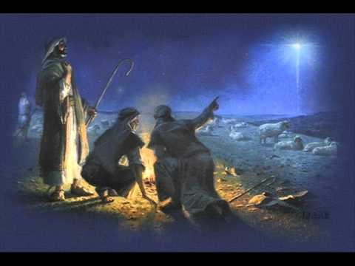

Night Watch

Water
Of
Life

24 December 2017

W A T E R O F L I F E

Independent Christian Church—Conservative Lutheran Doctrine

Worship Service: 9:30 a.m. Bible Study: 10:45 a.m.

Larry Cooper, Pastor E-Mail address:
111 N. Ridge Road lcooper@wateroflife.cc
Coon Valley, WI 54623 Web Site:
Phone: (608) 452-2105 www.wateroflife.cc

* * * * * * * * * * * * * * * * * * * * * * * * * * *

Sermon Text: Daniel 2:19-23

A Night Vision

* * * * * * * * * * * * * * * * * * * * * * * * * * *

Daniel 2:19 Then was the secret revealed unto Daniel in a night vision. Then Daniel blessed the God of heaven.

Related Reading: Job 12

12 With the ancient is wisdom; and in length of days understanding.
13 With him is wisdom and strength, he hath counsel and understanding.
14 Behold, he breaketh down, and it cannot be built again: he shutteth up a man, and there can be no opening.
15 Behold, he withholdeth the waters, and they dry up: also he sendeth them out, and they overturn the earth.
16 With him is strength and wisdom: the deceived and the deceiver are his.
17 He leadeth counsellors away spoiled, and maketh the judges fools.
18 He looseth the bond of kings, and girdeth their loins with a girdle.
19 He leadeth princes away spoiled, and overthroweth the mighty.
20 He removeth away the speech of the trusty, and taketh away the understanding of the aged.
21 He poureth contempt upon princes, and weakeneth the strength of the mighty.
22 He discovereth deep things out of darkness, and bringeth out to light the shadow of death.
23 He increaseth the nations, and destroyeth them: he enlargeth the nations, and straiteneth them again.
24 He taketh away the heart of the chief of the people of the earth, and causeth them to wander in a wilderness where there is no way.
25 They grope in the dark without light, and he maketh them to stagger like a drunken man.

